Cube (Regular Hexahedron)
# Source: AI Source: Provided by: [Data Path: Persons Table -> ID Column: 1, Name_En Column: Motasem Essam] -> From: [ChatGPT] on [7/25/2026]
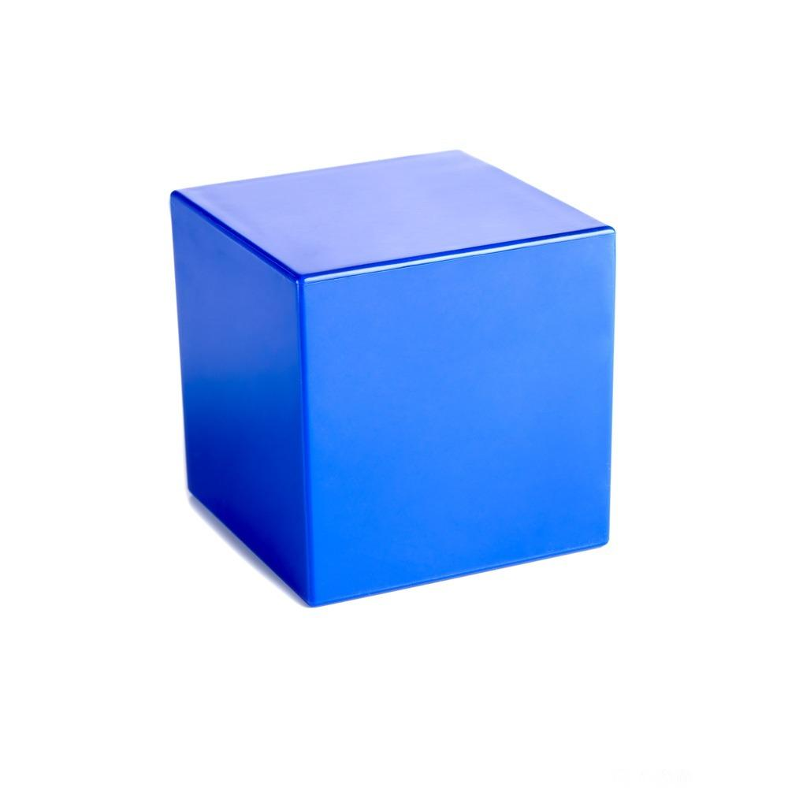
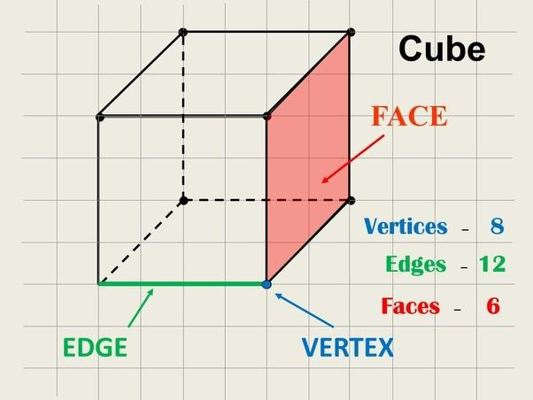
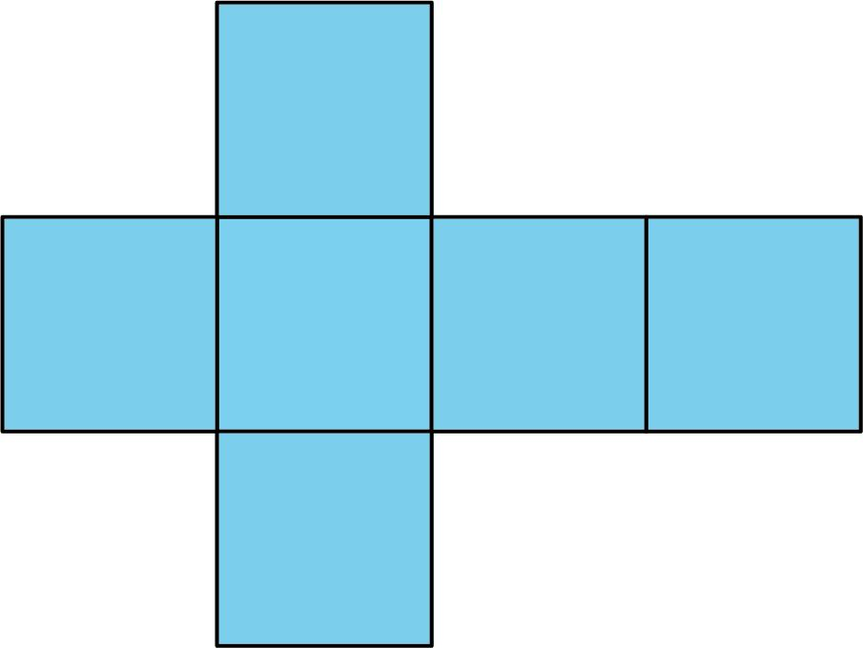

Definition
# Source: AI Source: Provided by: [Data Path: Persons Table -> ID Column: 1, Name_En Column: Motasem Essam] -> From: [ChatGPT] on [7/25/2026]
A cube, also called a regular hexahedron, is a three-dimensional convex polyhedron with six congruent square faces, twelve equal edges, and eight vertices.
It is one of the five Platonic solids because all its faces are identical regular polygons, and the same number of faces meet at every vertex.
The word hexahedron comes from Greek: hexa means six, and hedron means face.

Simple Definition
# Source: AI Source: Provided by: [Data Path: Persons Table -> ID Column: 1, Name_En Column: Motasem Essam] -> From: [ChatGPT] on [7/25/2026]
A cube is a solid shape with six equal square faces.
- Faces: 6 squares
- Edges: 12 equal line segments
- Vertices: 8 corners
Every face is a square, and every interior angle of each face is ${90}^{∘}$.

Key Characteristics
# Source: AI Source: Provided by: [Data Path: Persons Table -> ID Column: 1, Name_En Column: Motasem Essam] -> From: [ChatGPT] on [7/25/2026]
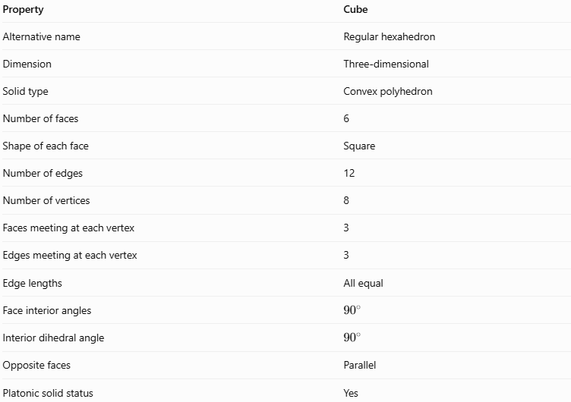
Property | Cube
Alternative name | Regular hexahedron
Dimension | Three-dimensional
Solid type | Convex polyhedron
Number of faces | 6
Shape of each face | Square
Number of edges | 12
Number of vertices | 8
Faces meeting at each vertex | 3
Edges meeting at each vertex | 3
Edge lengths | All equal
Face interior angles | \(90^\circ\)
Interior dihedral angle | \(90^\circ\)
Opposite faces | Parallel
Platonic solid status | Yes

Geometric Representation
# Source: AI Source: Provided by: [Data Path: Persons Table -> ID Column: 1, Name_En Column: Motasem Essam] -> From: [ChatGPT] on [7/25/2026]
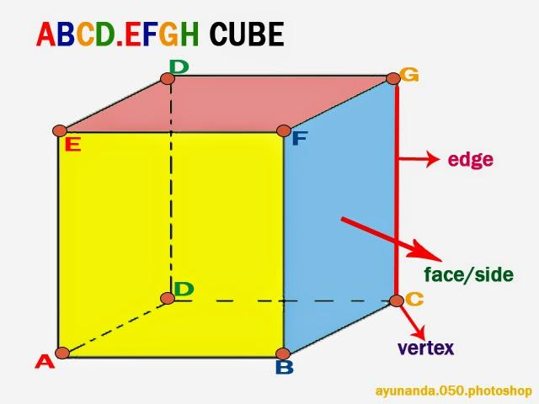
A cube can be represented using eight vertices labeled $A,B,C,D,E,F,G,H$, with corresponding vertices on its two parallel square faces.
For example, consider a cube whose bottom face is $ABCD$ and whose top face is $EFGH$.
Faces
The six square faces are:
- Bottom: $ABCD$
- Top: $EFGH$
- Front: $ABFE$
- Back: $DCGH$
- Left: $ADHE$
- Right: $BCGF$
The exact labels depend on how the cube is drawn.
Edges
A cube has twelve edges:
- Four edges on the bottom face.
- Four edges on the top face.
- Four edges connecting the corresponding vertices of the two faces.
Vertices
The cube has eight vertices. Each vertex is shared by three faces and is where three edges meet.

Mathematical Representations and Formulas
# Source: AI Source: Provided by: [Data Path: Persons Table -> ID Column: 1, Name_En Column: Motasem Essam] -> From: [ChatGPT] on [7/25/2026]
Let:
- $a$ = edge length
- $A_{f}$ = area of one face
- $A_{T}$ = total surface area
- $V$ = volume
- $d_{f}$ = face diagonal
- $d_{s}$ = space diagonal

Number of faces, edges, and vertices
# Source: AI Source: Provided by: [Data Path: Persons Table -> ID Column: 1, Name_En Column: Motasem Essam] -> From: [ChatGPT] on [7/25/2026]
$$F=6, E=12, V_{e}=8$$
Euler's formula for convex polyhedra is:
$$V_{e}-E+F=2$$
Substituting the cube's values:
$$8-12+6=2$$
Therefore, the cube satisfies Euler's formula.

Area of one face
# Source: AI Source: Provided by: [Data Path: Persons Table -> ID Column: 1, Name_En Column: Motasem Essam] -> From: [ChatGPT] on [7/25/2026]
Each face is a square of side length $a$:
$$\boxed{A_{f}=a^{2}}$$

Total surface area
# Source: AI Source: Provided by: [Data Path: Persons Table -> ID Column: 1, Name_En Column: Motasem Essam] -> From: [ChatGPT] on [7/25/2026]
A cube has six congruent square faces:
$$A_{T}=6A_{f}$$
Therefore:
$$\boxed{A_{T}=6a^{2}}$$

Volume
# Source: AI Source: Provided by: [Data Path: Persons Table -> ID Column: 1, Name_En Column: Motasem Essam] -> From: [ChatGPT] on [7/25/2026]
The volume is the product of the three equal dimensions:
$$V=a×a×a$$
Therefore:
$$\boxed{V=a^{3}}$$

Face diagonal
# Source: AI Source: Provided by: [Data Path: Persons Table -> ID Column: 1, Name_En Column: Motasem Essam] -> From: [ChatGPT] on [7/25/2026]
The face diagonal is the diagonal across one square face. Using the Pythagorean theorem:
$$d_{f}^{2}=a^{2}+a^{2}$$
Hence:
$$\boxed{d_{f}=a\sqrt{2}}$$

Space diagonal
# Source: AI Source: Provided by: [Data Path: Persons Table -> ID Column: 1, Name_En Column: Motasem Essam] -> From: [ChatGPT] on [7/25/2026]
The space diagonal connects two opposite vertices through the interior of the cube.
Using the face diagonal and the third edge:
$$d_{s}^{2}=d_{f}^{2}+a^{2}$$
$$d_{s}^{2}=2a^{2}+a^{2}=3a^{2}$$
Therefore:
$$\boxed{d_{s}=a\sqrt{3}}$$

Total edge length
# Source: AI Source: Provided by: [Data Path: Persons Table -> ID Column: 1, Name_En Column: Motasem Essam] -> From: [ChatGPT] on [7/25/2026]
Since the cube has twelve equal edges:
$$\boxed{L=12a}$$

Radius of the circumscribed sphere
# Source: AI Source: Provided by: [Data Path: Persons Table -> ID Column: 1, Name_En Column: Motasem Essam] -> From: [ChatGPT] on [7/25/2026]
A sphere passing through all eight vertices of the cube has radius equal to half the space diagonal:
$$\boxed{R=\frac{a\sqrt{3}}{2}}$$
The inscribed sphere, which touches the center of each face, has radius:
$$\boxed{r=\frac{a}{2}}$$

Worked Examples
# Source: AI Source: Provided by: [Data Path: Persons Table -> ID Column: 1, Name_En Column: Motasem Essam] -> From: [ChatGPT] on [7/25/2026]
Example 1: Counting geometric elements
Problem: How many faces, edges, and vertices does a cube have?
Solution:
- Faces: $F=6$
- Edges: $E=12$
- Vertices: $V_{e}=8$
Check Euler's formula:
$$8-12+6=2$$
Answer: 6 faces, 12 edges, and 8 vertices.
Example 2: Calculating total surface area
Problem: A cube has an edge length of $5\text{ cm}$. Find its total surface area.
Formula:
$$A_{T}=6a^{2}$$
Substitution:
$$A_{T}=6{\left(5\right)}^{2}=6\left(25\right)$$
$$\boxed{A_{T}=150{\text{ cm}}^{2}}$$
Example 3: Calculating volume
Problem: Find the volume of a cube with an edge length of $4\text{ cm}$.
Formula:
$$V=a^{3}$$
Substitution:
$$V=4^{3}=4×4×4$$
$$\boxed{V=64{\text{ cm}}^{3}}$$
Example 4: Calculating the space diagonal
Problem: A cube has an edge length of $6\text{ cm}$. Find its space diagonal.
Formula:
$$d_{s}=a\sqrt{3}$$
Substitution:
$$d_{s}=6\sqrt{3}$$
$$\boxed{d_{s}≈10.39\text{ cm}}$$
Example 5: Finding the edge length from the volume
Problem: A cube has a volume of $125{\text{ cm}}^{3}$. Find its edge length.
Formula:
$$V=a^{3}$$
Rearrange:
$$a=\sqrt[3]{V}$$
Substitute:
$$a=\sqrt[3]{125}=5$$
Answer: $a=5\text{ cm}$.

Comparison with Related Geometric Solids
# Source: AI Source: Provided by: [Data Path: Persons Table -> ID Column: 1, Name_En Column: Motasem Essam] -> From: [ChatGPT] on [7/25/2026]
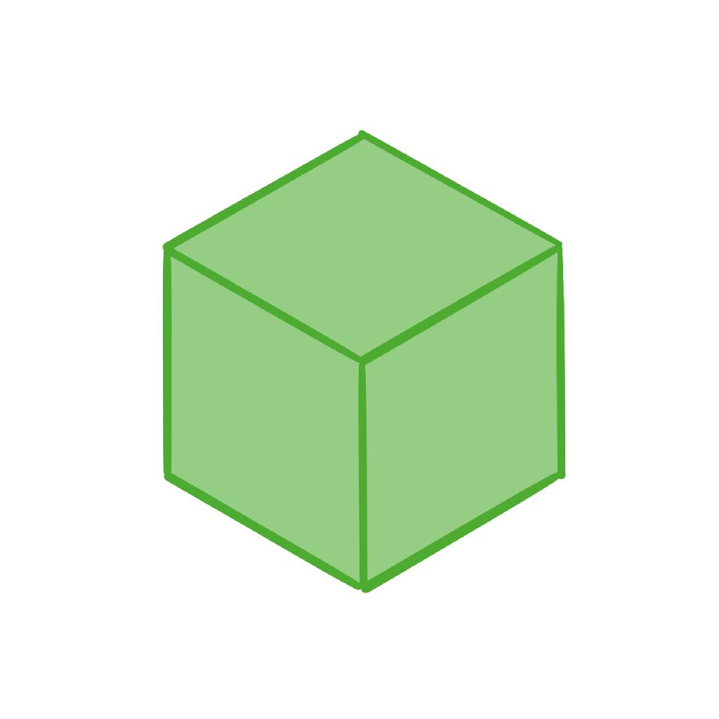
Cube (Regular Hexahedron)
6 square faces · 12 equal edges · 8 vertices
All edges are equal, and all six faces are congruent squares.
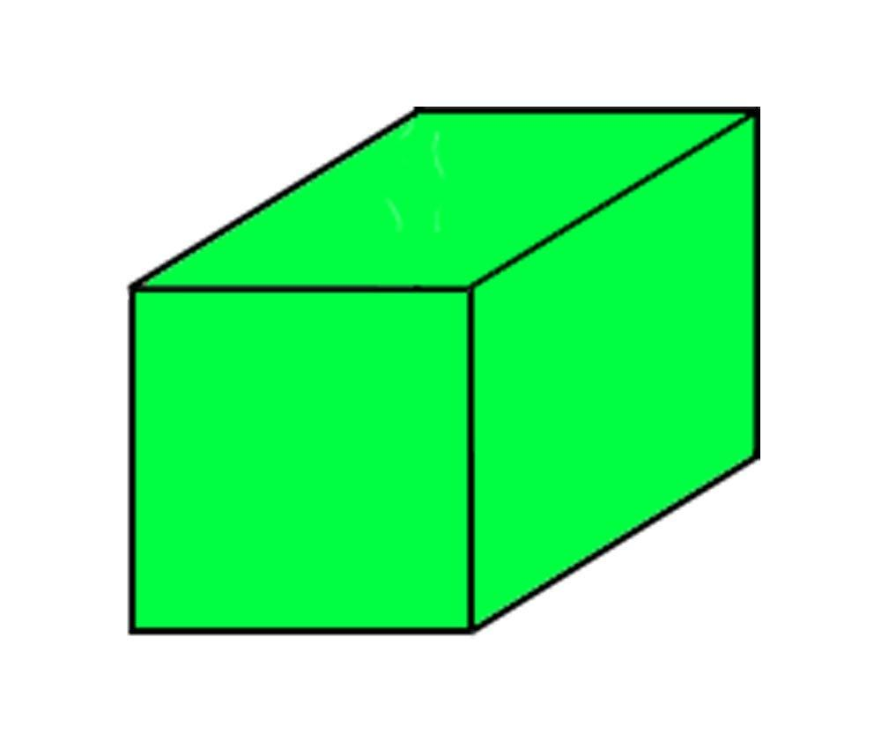
Rectangular Prism (Cuboid)
6 rectangular faces · 12 edges · 8 vertices
Its length, width, and height can differ. A cube is a special rectangular prism whose dimensions are all equal.
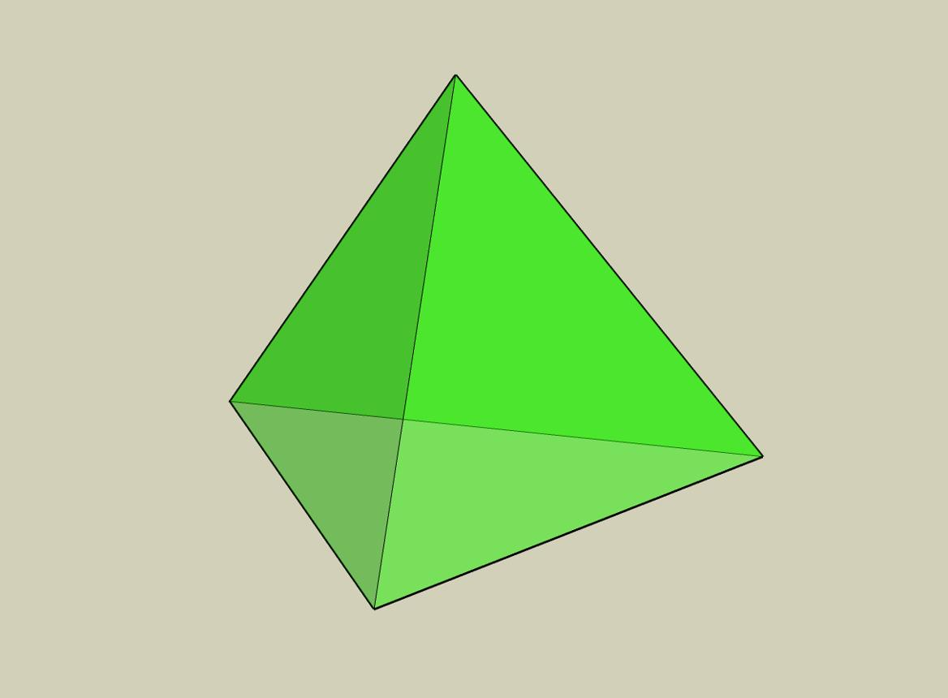
Tetrahedron
4 triangular faces · 6 edges · 4 vertices
Another Platonic solid, but its faces are equilateral triangles rather than squares.

The Cube Among the Five Platonic Solids
# Source: AI Source: Provided by: [Data Path: Persons Table -> ID Column: 1, Name_En Column: Motasem Essam] -> From: [ChatGPT] on [7/25/2026]
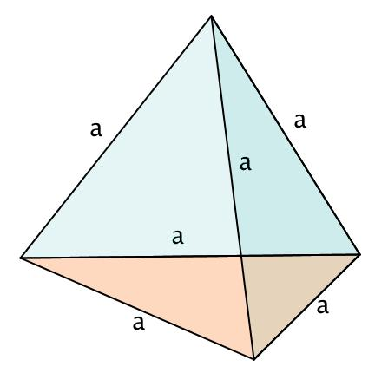
1. Tetrahedron
4 equilateral-triangle faces
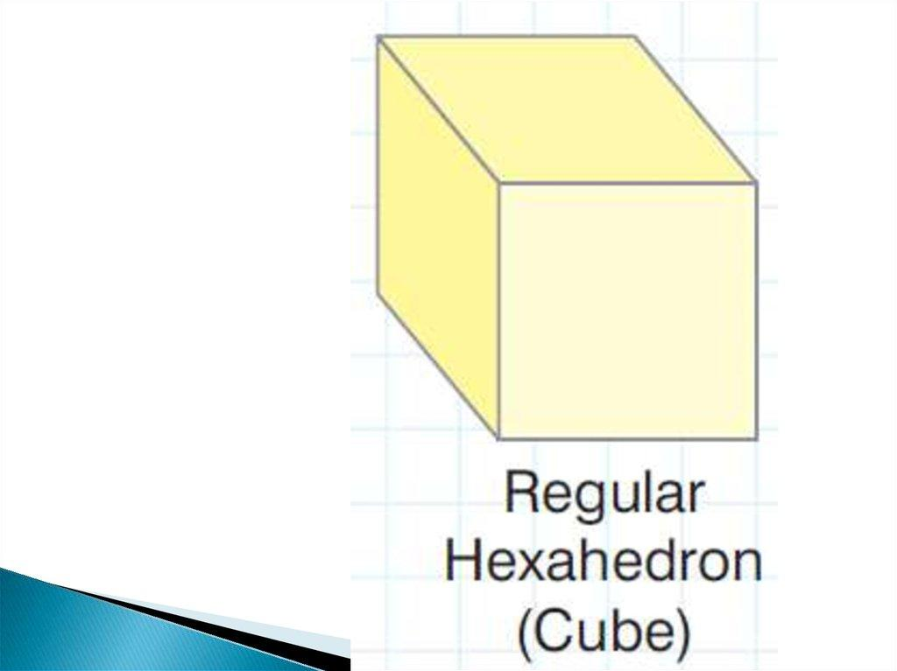
2. Cube (Hexahedron)
6 square faces
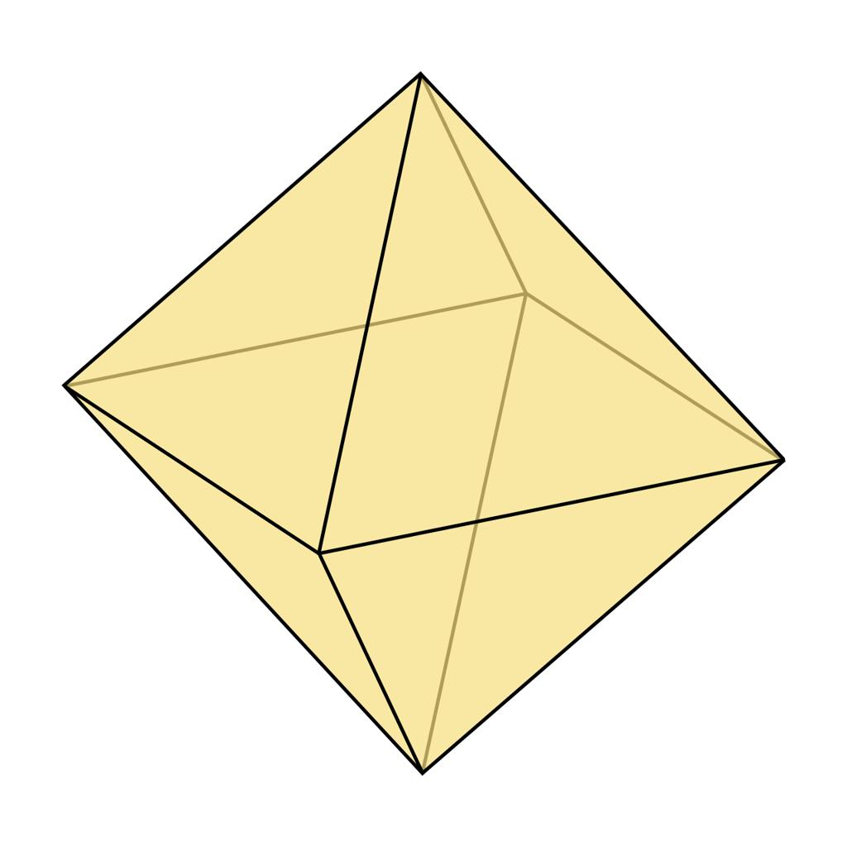
3. Octahedron
8 equilateral-triangle faces
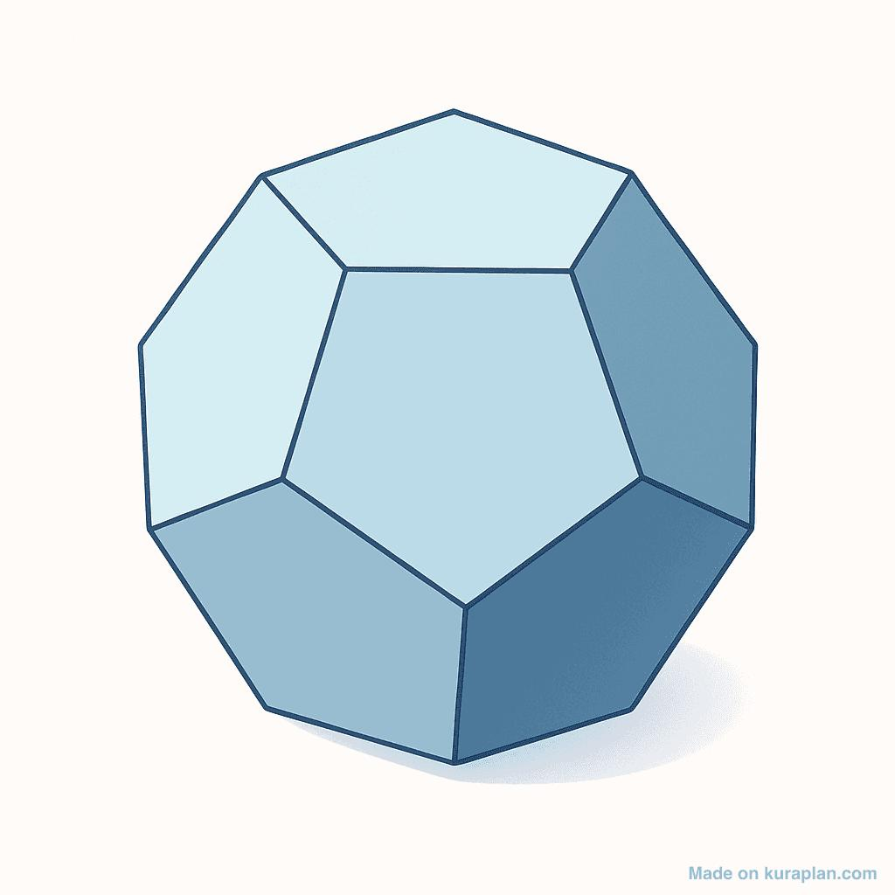
4. Dodecahedron
12 regular pentagonal faces
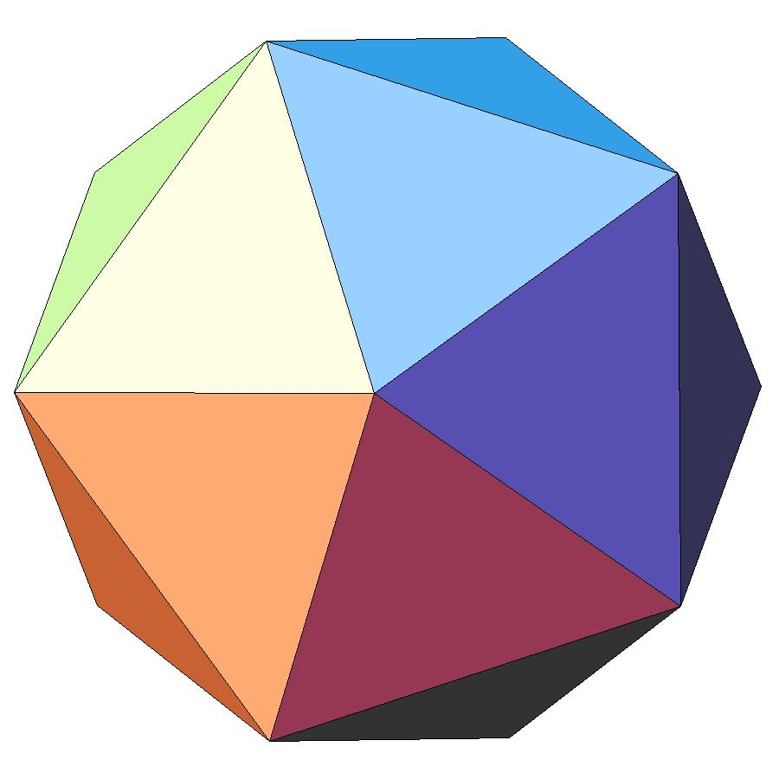
5. Icosahedron
20 equilateral-triangle faces
The cube is the only Platonic solid whose faces are squares. Three square faces meet at every vertex.

Constructing Cube in Solid Geometry

Instruments Used
# Source: AI Source: Provided by: [Data Path: Persons Table -> ID Column: 1, Name_En Column: Motasem Essam] -> From: [ChatGPT] on [7/25/2026]
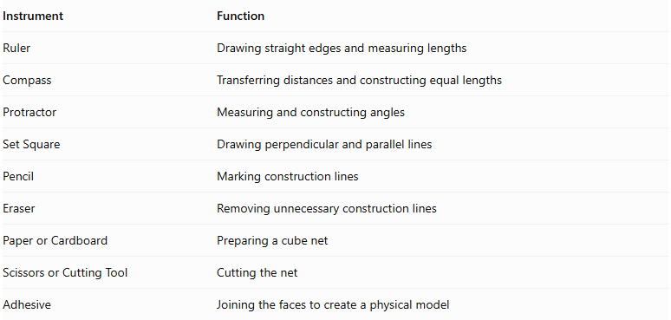
Instrument | Function
Ruler | Drawing straight edges and measuring lengths
Compass | Transferring distances and constructing equal lengths
Protractor | Measuring and constructing angles
Set Square | Drawing perpendicular and parallel lines
Pencil | Marking construction lines
Eraser | Removing unnecessary construction lines
Paper or Cardboard | Preparing a cube net
Scissors or Cutting Tool | Cutting the net
Adhesive | Joining the faces to create a physical model

Construction Procedures

A. Face-Based Construction
# Source: AI Source: Provided by: [Data Path: Persons Table -> ID Column: 1, Name_En Column: Motasem Essam] -> From: [ChatGPT] on [7/25/2026]
- Draw a square using a ruler and set square.
- Determine the required edge length.
- Draw a second congruent square to represent the opposite face, offsetting it to indicate depth.
- Connect the four corresponding vertices of the two squares.
- Complete the remaining edges.
- Identify visible and hidden edges.
- Darken the final cube outline.
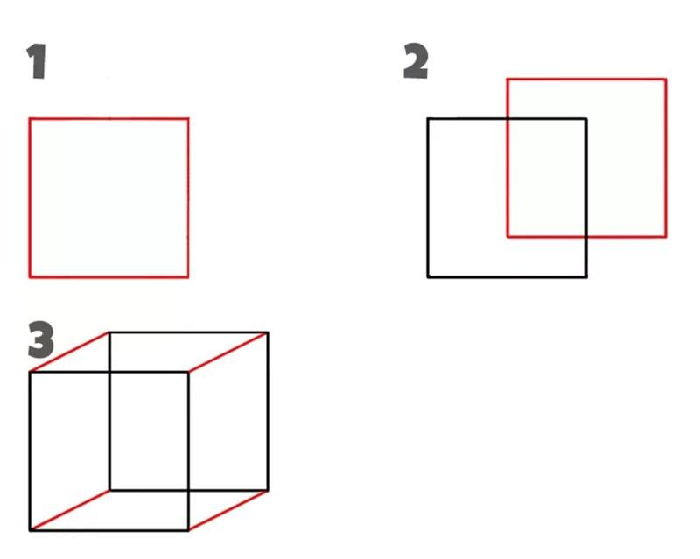

B. Edge-Based Construction
# Source: AI Source: Provided by: [Data Path: Persons Table -> ID Column: 1, Name_En Column: Motasem Essam] -> From: [ChatGPT] on [7/25/2026]
- Draw one edge representing the required cube side length.
- Construct perpendicular edges of equal length at its endpoints.
- Complete the first square face.
- Construct the corresponding opposite face.
- Connect corresponding vertices.
- Verify that all twelve edges have equal lengths.

C. Vertex-Based Construction
# Source: AI Source: Provided by: [Data Path: Persons Table -> ID Column: 1, Name_En Column: Motasem Essam] -> From: [ChatGPT] on [7/25/2026]
- Establish the eight vertices of the cube using geometric measurements and construction relationships.
- Arrange the vertices into two groups of four.
- Connect the four vertices of each group to form two square faces.
- Connect corresponding vertices between the two faces.
- Complete the twelve edges.
- Identify hidden edges where necessary.

D. Diagonal-Based Construction
# Source: AI Source: Provided by: [Data Path: Persons Table -> ID Column: 1, Name_En Column: Motasem Essam] -> From: [ChatGPT] on [7/25/2026]
- Construct a square face using its diagonal and geometric relationships.
- Determine the cube edge length from the square diagonal.
- Construct the opposite square face.
- Connect corresponding vertices.
- Construct or verify the space diagonals.
- Check the equality of the four space diagonals.

E. Net-Based Construction
# Source: AI Source: Provided by: [Data Path: Persons Table -> ID Column: 1, Name_En Column: Motasem Essam] -> From: [ChatGPT] on [7/25/2026]
- Draw six congruent squares.
- Arrange the squares in one of the eleven distinct cube-net arrangements.
- Add joining tabs if preparing a physical model.
- Cut out the net.
- Fold along the shared edges.
- Join the appropriate edges.
- Complete the six-faced cube.
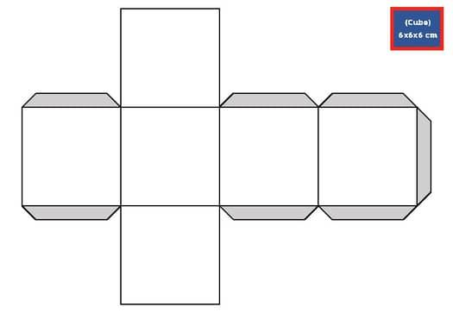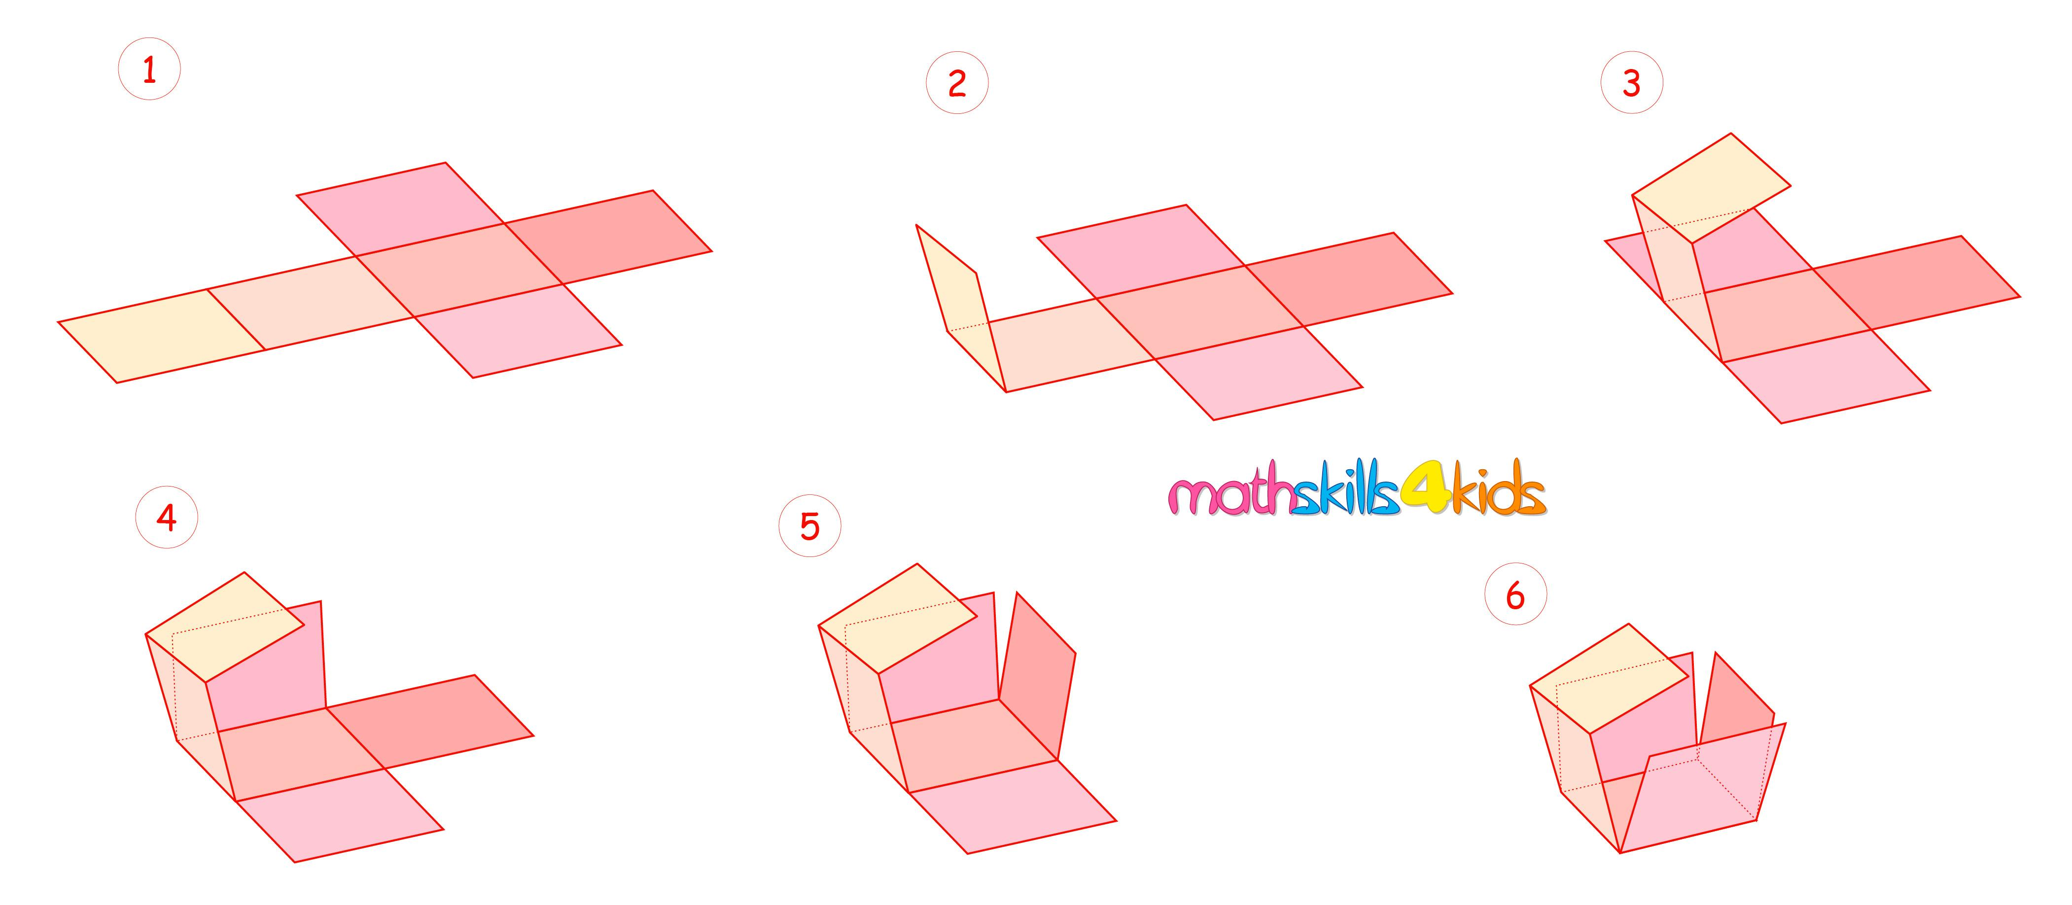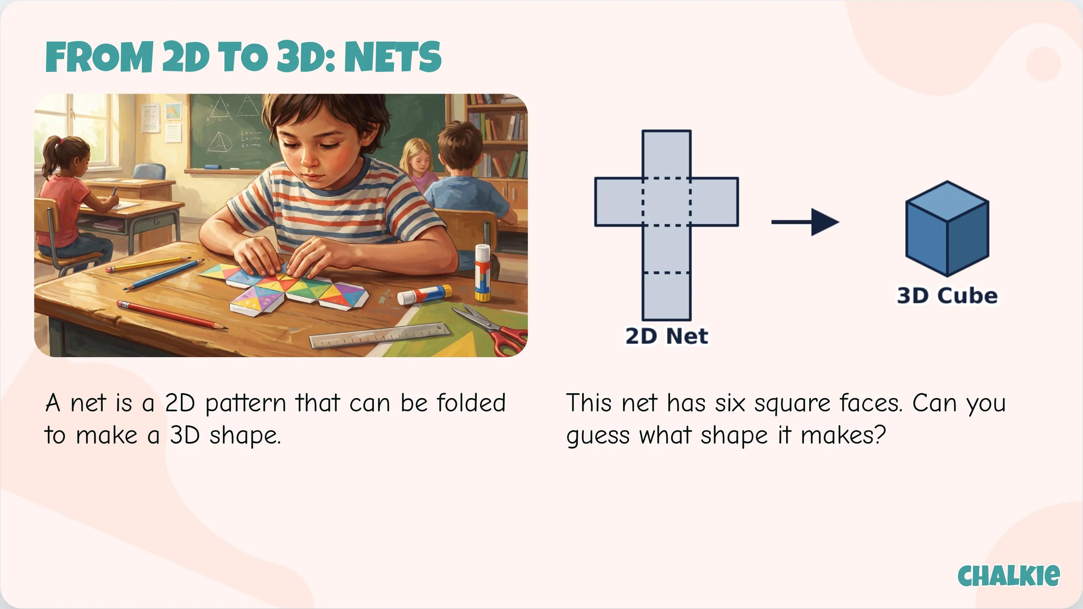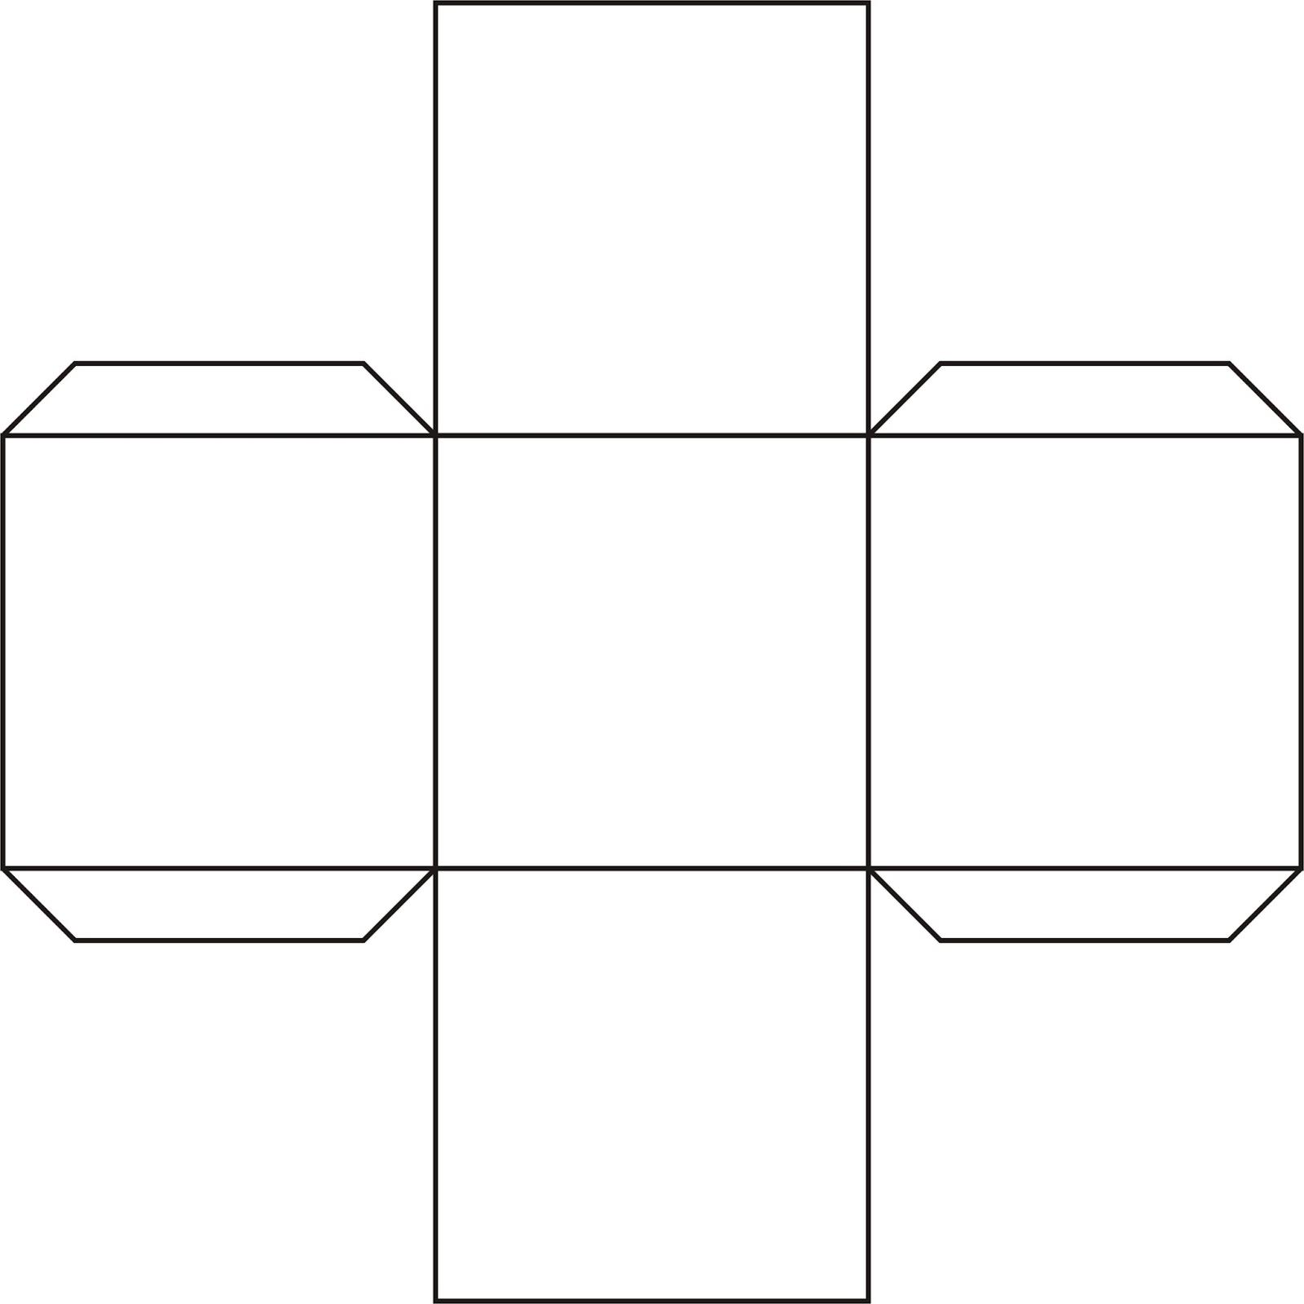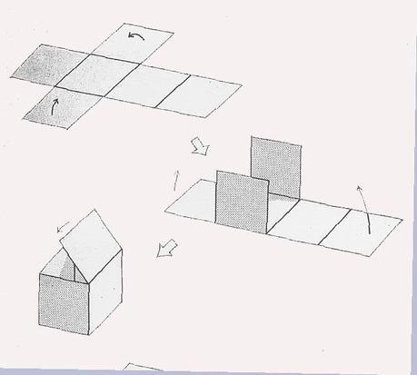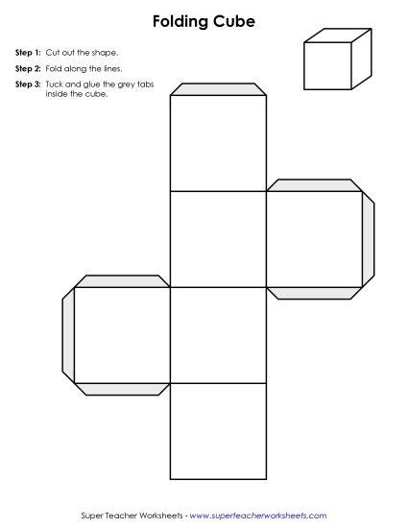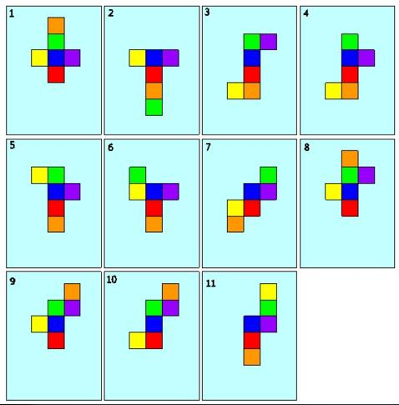

F. Physical Model Construction
# Source: AI Source: Provided by: [Data Path: Persons Table -> ID Column: 1, Name_En Column: Motasem Essam] -> From: [ChatGPT] on [7/25/2026]
- Prepare six congruent square pieces or a suitable cube net.
- Measure and cut all pieces to equal dimensions.
- Join the six square faces along their corresponding edges.
- Assemble the faces into a closed solid.
- Check that all edges are equal and all faces are square.
- Verify that the completed model has eight vertices.

Applications of the Cube
# Source: AI Source: Provided by: [Data Path: Persons Table -> ID Column: 1, Name_En Column: Motasem Essam] -> From: [ChatGPT] on [7/25/2026]
- Architecture and construction: used in modular structures and cubic building designs.
- Packaging and storage: cubic boxes provide a practical shape for storing and transporting objects.
- Mathematics education: helps teach surface area, volume, diagonals, and spatial reasoning.
- Computer graphics: used in 3D modeling, voxel systems, and spatial grids.
- Games: standard six-sided dice are commonly cube-shaped, although their numbering and use are separate from the cube's geometric definition.
- Crystallography: cubic symmetry describes several crystal structures.

Key Points
# Source: AI Source: Provided by: [Data Path: Persons Table -> ID Column: 1, Name_En Column: Motasem Essam] -> From: [ChatGPT] on [7/25/2026]
- A cube is also called a regular hexahedron.
- It is one of the five Platonic solids.
- It has 6 square faces, 12 equal edges, and 8 vertices.
- Three faces meet at every vertex.
- Total surface area: $A_{T}=6a^{2}$.
- Volume: $V=a^{3}$.
- Face diagonal: $d_{f}=a\sqrt{2}$.
- Space diagonal: $d_{s}=a\sqrt{3}$.
- It satisfies Euler's formula: $V_{e}-E+F=2$.
- Every cube is a rectangular prism, but not every rectangular prism is a cube.

Conclusion
# Source: AI Source: Provided by: [Data Path: Persons Table -> ID Column: 1, Name_En Column: Motasem Essam] -> From: [ChatGPT] on [7/25/2026]
The cube (regular hexahedron) is a fundamental Platonic solid distinguished by its six congruent square faces and twelve equal edges. Its symmetry and straightforward formulas make it useful for understanding three-dimensional geometry, including surface area, volume, diagonals, and polyhedral structure. It also provides a useful comparison with the other four Platonic solids.

